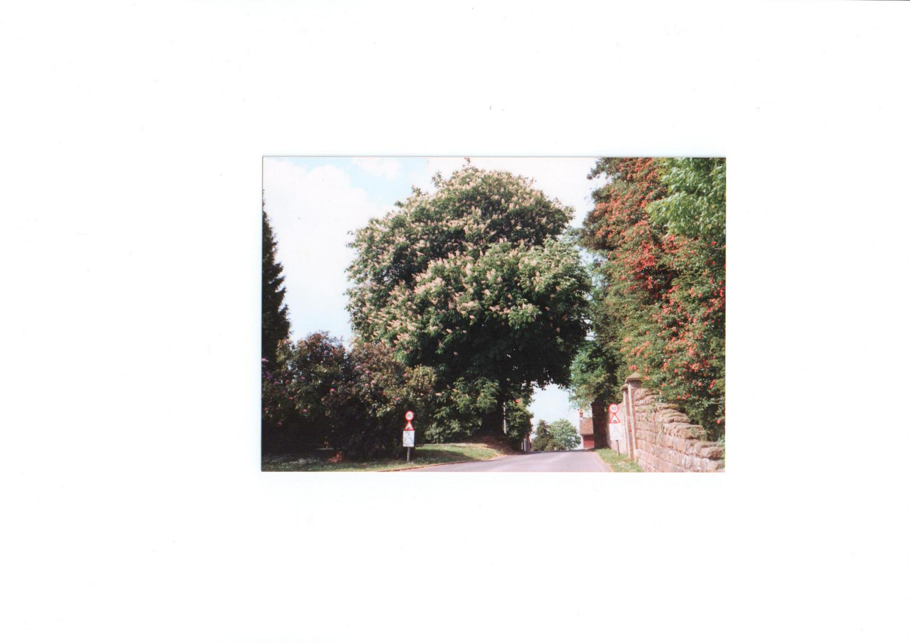
TURNERS HILL PARK
60th ANNIVERSARY DIAMOND JUBILEE
COMMEMORATIVE BROCHURE

Written and produced by
The Turners Hill Park Residents Committee
June 2012

The Other Diamond Jubilee

In 2011 Turners Hill Park achieved 60 years as a residential park, something that passed us all by until, during a discussion with Allan Peacock, we both suddenly realised that the park had been in existence since 1951. The Residents Association then decided to try and mark the occasion by producing a ‘Jubilee Booklet’, river pageants being a little out of our league! We have, therefore, put these memories and other ‘happenings’ together using Allan’s scrapbook, old newsletters and minutes, the 50 years booklet put together by Linda, as well as memories and stories from residents especially stories about the pantomimes put on in the club every year, (the photographs of which have to be seen to be believed!). It is obvious from these photos that a good time was had by all. Special thanks go to Linda Furzer for her knowledge of the park and her assistance in putting all this together, Allan Peacock for his scrapbook, photographs and his memories and Sheila Caldwell for putting my writing together in a readable form together with the illustrations.
Jennie Forbes, 2012.

The 1950’s.
The park founder, Mr Derick Huxley started the park in 1951, having a few years previously, with his then fiancée visited a farm sale in Surrey that was also a caravan site (as they were then called). In fact Mr Huxley and his wife themselves first lived in a caravan after their marriage. What is now Turners Hill Park was then owned by Mr Huxley’s father, the family farmed locally and he described it as ’38 acres of scrubland’. Derick Huxley took the land in lieu of a £200 debt and applied to the local council for permission for 20 residential caravans. He was given temporary permission and so Turners Hill Park was born.
Derick Huxley had a vision. The site that he envisioned was one where every caravan would have privacy and an individual setting. Each caravan would have its own flush lavatory, mains water, a hardstanding and electricity. Remember this was 1951, when many bricks and mortar homes still did not have indoor toilets or bathrooms. He moved his family onto the site where they also lived in a caravan, fenced off part of the land and laid out lawns and gardens. He created a pattern for caravan sites that many other owners followed. Within six months, Turners Hill Caravan Estate (as it was called) was well under way. In 1954 he applied for permission to site 30 ‘holiday homes’ and this was granted for five years. The estate was increased to 50 acres and the scrubland was thinned out. Each lane, avenue and crescent was originally cinder paths named by Mr Huxley after birds. The caravans were tucked away and screened from neighbours by the woodland. Had they not been screened, the then local authority would have attempted to close the site. In fact in 1957, they declared the site a ‘sub standard housing estate’ but one official attempting to count the caravans, couldn’t find them all in the woodland!

The 1960’s
In 1962 Mr Huxley won planning permission for 100 mobile homes and 60 holiday caravans after a seven hour appeal hearing. An article in the then ‘Mobile Home’ magazine interviewed several residents, some in their eighties, some newly married, but all spoke highly of their lives at Turners Hill. One of the homes mentioned was a ‘Sipson’ a make still found on the park today, another a ‘Mayflower’ is quoted as costing £650 and the rent was 30s (£1.50) a week with no ‘rates’. How times change! The article includes a photograph of the club, looking very familiar, but without the hedge, office and shop alongside. Where the club now stands was originally kennels and sheds because what is now Homewood was originally known as ‘The Bothy’ and had been the gamekeeper’s cottages. The oldest part of the park is Blackbird Hill and Wren Street but, when you look at old aerial photographs, homes are also seen along what is now Lark Rise, Nightingale Lane, Finch Crescent and Tom Tit Crescent.

The Park Rules for 1962 make enjoyable reading. Residents were referred to as ‘Caravanners’, but otherwise are very similar to the Park Rules that we still have today, with the exception that one rule states that ‘Caravanners' must not dispose of any sanitary pail or chemical closet except at a place stated by the management in conformity with the instructions of the Local Authority’!
An advertising leaflet of the period, probably mid to late sixties, quotes the ‘Park Services fee’ as £13.0s.0d per calendar month with connecting and siting fees of £300 inclusive and security of tenure agreements. The touring section was 7/6d (37½p) to 12/6d (62´½p) depending on the season.
A residential mobile home had to be over 30ft in length or a double unit and £1,500 ex works, complying with British Standards 3632 to ‘ensure that a high standard is kept on this park’! New roads had obviously been laid by then as the leaflet refers to tarmac roads and street lighting. Amenities refer to a ‘general store’, licensed club and ‘accessory shop’. Because the homes were dotted around the park and were numbered sporadically, post was delivered to the office. In 1969, Turners Hill appeared in a French mobile homes magazine as an ‘example de parc prive’. The photographs, as advised by Allan, were taken from the top of Blackbird Hill and the corner of Nuthatch Way/ Wren Street.
Mr Huxley lived for a while in what is now Homewood and then moved to ‘Lanterns’ along the lane which he had built. In 1967 he became Chairman of the National Caravan Council and served for several years on the Executive Council.

1970’s
In December 1970 Mr Huxley sold the park to Greens (Breach Barns) and eventually moved to Cornwall. An article in the then Mobile Home magazine cited Turners Hill as a ‘showplace site between Crawley and East Grinstead’. By then the park was licensed for 140 mobile homes, permission having been given in 1973 for an extra 50 homes.
Godfrey Davis bought the park in 1976 and, if you talk to older residents, they will refer to this period as the best time on the park. In 1976 an application was made to use woodland to extend the park. The application was refused on appeal.
The 70’s were obviously a quiet time at Turners Hill because there is very little history on this period. Although, in the leaflet by Eric Dawes that details the creation of Turners Hill Parish Council, it is mentioned that, in 1976, a Mr Syd Amey, (who co-incidentally lived where 5 Turtledove Avenue now sits) the then Chairman of ‘The Park’ Resident Association, was approached to support a Ward Advisory Committee to discuss various issues that affected the Village. This Committee also organised the Queen’s Silver Jubilee celebrations. The first Tree Protection Order was made in 1976 and the map describing the Order on the east side of the park, shows that Woodpecker Way, Linnet Close and one side of Partridge Place (backing onto Lark Rise) were already in place. From records that Allan Peacock has unearthed, we know that the 50 homes on these roads were developed between 1976 and 1979.

1980’S
- The eighties were certainly busy years for the park. In 1980, 19 homes were developed in part of Partridge Place, Nightingale Lane, Lark Rise and Kingfisher Lane.
- Syd Amey joined the Ward Committee as a member in 1981, thus starting the park’s link with the Parish Council
- In 1984 Allan Peacock and his wife Carol came to the park. At the time Allan also managed four other parks. Allan started the Garden Competitions and when I asked him about them he said ‘it seemed a good idea at the time’. The Rose Bowl was presented by Godfrey Davis Home Estates and was presented in the Club by the then Managing Director, W D Jackson. The gardens were judged by him and his wife. From the many photographs held by Allan, the Competitions certainly gave a lot of pleasure to the gardeners on the park. During this year the dreaded speed humps were mentioned for the first time,
- In January 1985 the first discussion with the then County Council concerning the speed on the B2110 took place. Part of the discussion also concerned the hedge at Fen Place (Alexander House). Some things never change!

- Autumn 85 brought the one - way road system to Robin Row, Turtledove Avenue and Lark Rise and the road humps were agreed. There was a fire in Linnet Close and Kingfisher Lane featured in Choice Magazine. The pitch rent at the time was £6.50 to £11.00

- 1986 - 88 brought sodium street lighting (previously the street lighting had been strung between the trees) and the footpath to the village was first discussed. In October 1987, number 1 Finch Crescent was the front cover page of the Mobile and Holiday homes magazine and, of course, the park was badly damaged in the 87 storm and many trees were lost. In 1988, an article in the Mobile Homes magazine written by
Ian Lamberton, the then Chairman of the Residents Association, praises the community spirit of residents at the time of the storm and also the park staff. Believe it or not a request was made in 1988 for a tree to be planted in every garden!
- Berkeley Leisure Group bought the park in 1988.
- In March 89, the development of the land behind Woodpecker Way by the ‘Twitten’ was proposed as well as the area then used for touring caravans (now Siskin Avenue). The then Residents Association Committee went to the Parish Council to oppose the application. The application was refused.
- The first plans for the extension to the Alexander House Hotel were put to Mid Sussex Council.
- The Tree Preservation Order on the East side of the park replacing the one made in 1976 was put in place in August 1989.
- Kestrel Walk was developed in 1989 on land that originally held a barn where Mr Huxley’s daughter kept her horse and apples and other vegetables were stored.
- Petitions for a footpath to Turners Hill Village started during this period and an article in the local press at the time shows a group of determined residents, complete with placards, lobbying the County Council at Chichester. The article states that the County Council would press ahead with plans to compulsory purchase land from local farmers to re-align the road in order to accommodate the footpath. The plan was to commence work by April 1989. What would the walkers on the park do without that footpath nowadays; we all owe a large debt to these hardy protesters. The footpath was completed in 1990.

1990’s
- In March, Berkeley Leisure Group appealed against the planning refusal for the development behind Woodpecker Way and the touring caravan site ( now Siskin Avenue), on the grounds that first time buyers and young couples could afford this type of housing. Arthur Walters was elected to the Parish Council.
- In August, the park featured in the Mobile and Holiday Homes magazine with photographs of a very youthful Allan Peacock and other residents. The article included the new homes in Kestrel Walk (with the footpath still undeveloped) and interviews from residents on the park. Pitch fees were £18.12p a week. New homes cost between £35,000 and £64,000. Also included was a comment from the then Resident Association’s Chairman regarding the battle with the local authority concerning the poll tax (community charge). They were eventually successful; hence our council tax band is now category A.

- 1991 brought the door to door bus service to East Grinstead and Crawley.
- In early 1992 there was a burglary at the shop, the first mention of any such problem on the park and in October, television crews appeared on the park to landscape the garden of number 1 Nuthatch Way. November 1992 brought the second Tree Preservation Order on the West side of the park, thus ensuring that the whole of the park was protected, excepting what is now Siskin Avenue and the woodlands behind.
- In 1993, Geoff Furzer was elected Chairman of the Resident Association and the park contributed towards the cost of the seat along the footpath to the village.

- 1994 was a ‘red letter’ year. Gas came to Turners Hill, the 10mph speed limit was introduced and signs put up around the park and, in 1995, the new entrance road was completed.
- 1995 also brought the shopping bus to the park, although sadly this ceased in 1997. Geoff Furzer was co-opted on to the Parish Council and the development of Siskin Avenue started.
- In July 1997 the park address changed officially to Turners Hill Park and the Newsletter advised that wooden sheds were no longer allowed! That winter, the EG Bus commenced visiting the park for shopping trips on Friday afternoons.
- 1998 and the park achieved a Silver David Bellamy award, the assessors noting that the park had a ‘wide diversity of flora and fauna including scores of different bird species’ , the development of Siskin Avenue was completed and revised park rules were adopted after 28 days display
- In 1999, the park was awarded Gold David Bellamy award with David Bellamy himself visiting the park to present the award. Sandy Roffe was elected to the Parish Council.

The Millennium 2000
- 2001 brought a big change to the park. After the 28 days statutory notice, the park officially became a retirement park. Plans were still afoot at Alexander House and the Committee went to Mid Sussex Planning Committee to speak against plans for the hotel extension. A memorial tree was planted by the car park at Kestrel Walk to celebrate the parks 50 years anniversary. Moon Productions filmed a commercial on the park (Siskin Avenue) and the money paid to the park was used to provide a seat that can be seen at the bottom of Woodpecker Way.
- In 2003, Allan went into hospital for a heart operation and a temporary manager was installed. Mid Sussex Environmental Health Officers visited the park before issuing a new Site Licence in 2005. Alexander House submitted revised plans for the extension to the hotel and the very first ‘Dumper Truck’ came to the park! John and Wendy left the shop and the first Summer BBQ was organised as a ‘thank you’ leaving party for them both.
- In 2004 another memorial tree was planted on the green by the top of the park for Mary Wilcox, a founder member of the Resident Association and the park was plotted by Ordinance Survey for inclusion on the map. Recognition at last!
- 2005 and the first park walkabouts with Allan Peacock took place and the new Site Licence was issued.
- 2006 brought changes and amendments to the legislation that affects our homes.
- In 2007 The Residents Association was finally accepted as having ‘Qualified Status’ under the new rules. In the Autumn wheelie bins arrived! There was a meeting in the Club to discuss the shop as the current owners were threatening to close down. The shop closed just before Christmas.
- 2008, and the park won its 10th Gold David Bellamy award. In a newspaper article, Allan Peacock praised park residents for the way in which they fed the badgers and birds and looked after the wildlife on the park. Sadly, this was the last award that the park was allowed to apply for. Ray’s dairy came on to the park and provided a service for residents who could not get out and about.
- Joe purchased the shop and, after refurbishment, re-opened in August 2008. During 2008/9 major works were carried out to the electricity supplies of many homes on the park- this at the expense of Berkeley Leisure group. The works were needed to comply with new regulations. In 2009 the Residents Association began advisory talks from local groups.

- In 2010, the Residents Association asked the Parish Council whether they could provide a ‘garden’ refuse freighter. Lo and behold, they could! The first garden freighter arrived in April. In this year, we again started the campaign to have the speed limit reduced along East Street. The Residents Association held its first coffee morning at Christmas and presented Allan with a Weather Vane to commemorate the completion of the new workshop. Vee and his father took over the shop from Joe.
- In January 2011, the Residents Association took a Petition to the County Local Committee regarding the speed limit and, after discussions involving the Parish Council, were successful in having a 40mph limit agreed. The Government introduced the new Residential Tribunal system that has replaced the civil courts for the reconciliation of most disputes with park owners.
- This year also brought other changes. Allan took semi - retirement and we now have a new management structure on the park. Bruce Forbes was elected as District Councillor and Parish Councillor, Sandy Roffe, was re-elected to the Parish Council. The Government started an Inquiry into the legislation that affects our homes and the park experienced its first cattle stampede when a herd of cattle from the fields opposite decided to have a run on the park!
- 2012 and the speed limit on East Street (B2110) was finally introduced at the beginning of April. Consultation commenced on proposed changes to the legislation.

And here we are in the Queen’s Diamond Jubilee year
So, as can be seen, in 60 years the park has changed from a very small hamlet of 20 caravans and one man’s vision to a thriving community of 255 homes which makes up one-third of the village of Turners Hill. To look at old photographs of the park in the 50’s and 60’s it is hard to imagine life as it was then. There are several residents on the park who have lived here since the 1960’s and can remember those times. One of these, who has lived on the park for 51 years now, has told me some stories about those times and Mr Huxley, such as when he took meetings in the club, sitting on the stage and walking with her cat in the woods. She described it as ‘such a happy time’. Whilst talking to her the other day, she surprised me by telling me that she has lived in Turners Hill all her life. As a child she lived with her family in the cottages along East Street where they could look over the hedge to see whether the bus was coming and then run down to the road to wait for it to stop. It would be very difficult to do that nowadays, even with a 40mph speed limit!
It has been reported that over 63 different varieties of birds have been seen on the park along with badgers, pheasants and the ‘pesky deer’. Recently Allan Peacock has been advised of a new species of bird seen on the park, a Rock Sparrow. No wonder the park is renowned for its wildlife and 10 Gold David Bellamy awards. We, who now have the privilege of living at Turners Hill Park, owe a debt of gratitude to Derick Huxley and his vision.

Did you know?
That part of the old Roman road from London to the south coast runs under Nightingale Lane.
The land on which Turners Hill Park stands was originally the Home Park, part of the Fen Place estate. Clock Tower cottages at the top of the park were originally the Coach House and the grooms, later chauffeurs, lived above. The building was converted into cottages by Godfrey Davis. Fen Place farm was the ‘home farm’ to the estate and where Pots & Pithoi are now was the barn and piggery. The house became a home for retired clergy before becoming a hotel.
In 2009 there were 980 different types of garden ornaments on our park! They were counted as part of a survey by a young lady of 12 years (and her granddad), reason unknown and a copy was given to Allan for posterity.

June 2012

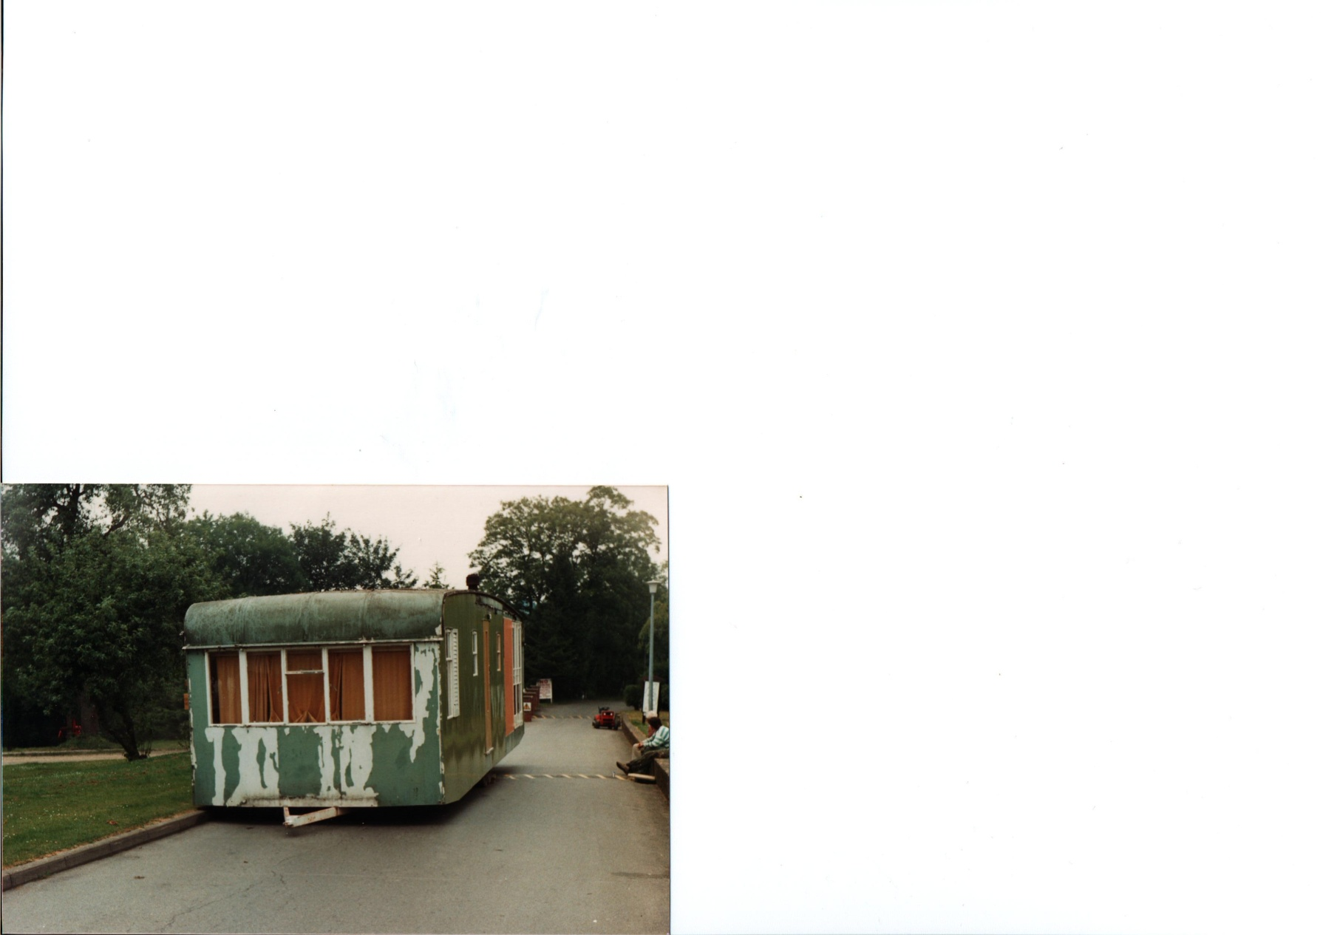

This is a very old unit which was taken off No. 20 Swallow Street.
It is parked just before the junction of Woodpecker/Puffin/ Nightingale.
On the left is the old Orchard where we all scrumped for apples and the
touring caravans used to be parked.
The wall where the chap is sitting belongs to the house ‘Homewood’.
NOW - the whole area has been redeveloped and is Siskin Avenue as we
know it today.

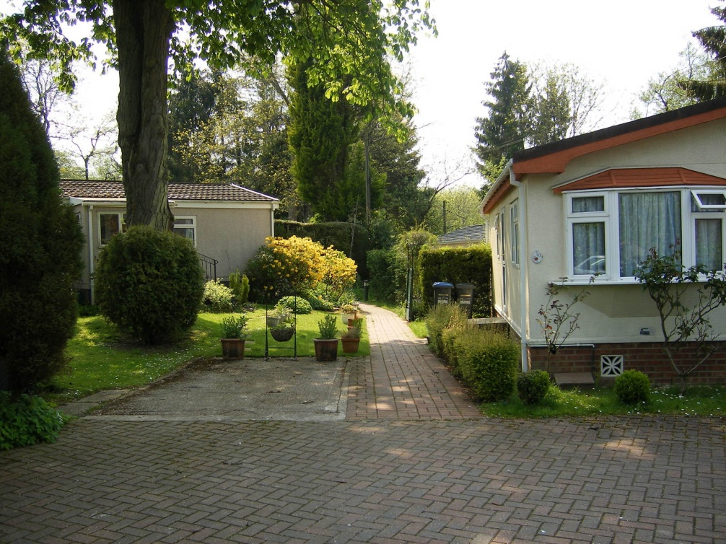
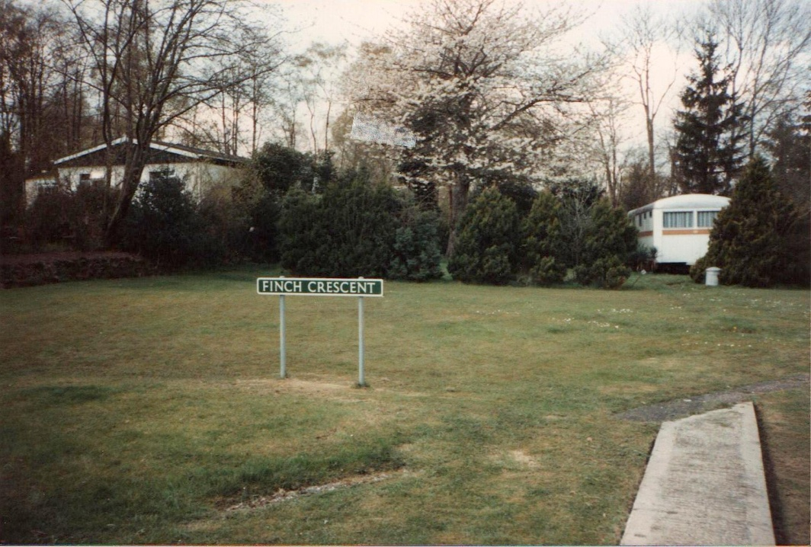

Finch before Development Finch Crescent after redevelopment
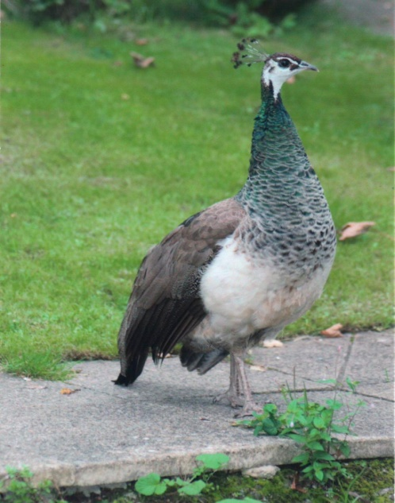
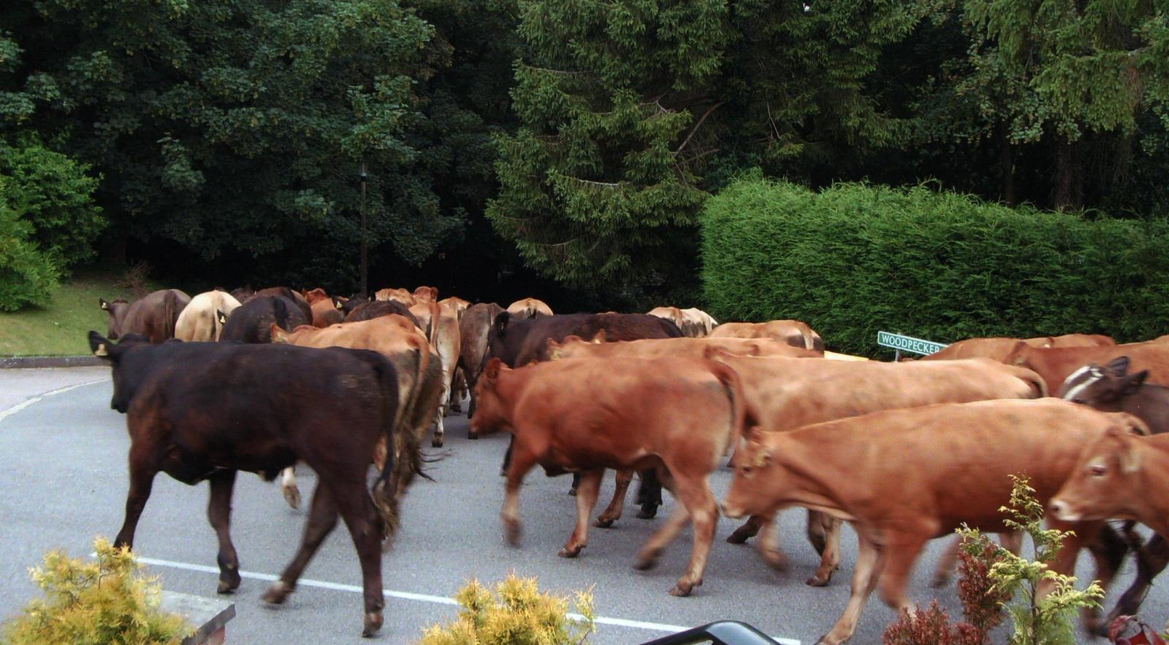
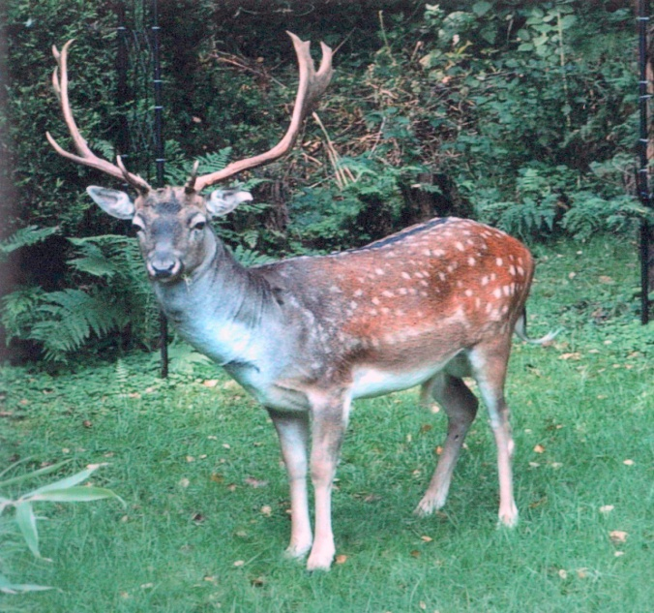
WILDLIFE ON OUR PARK
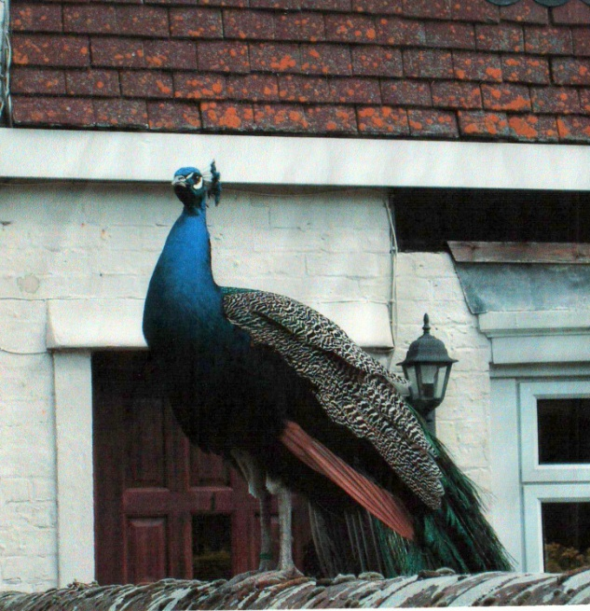
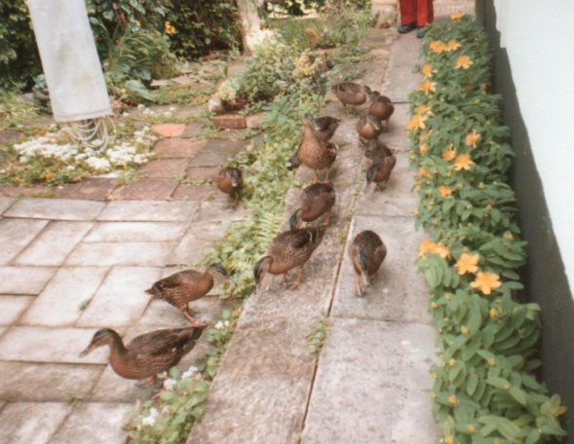
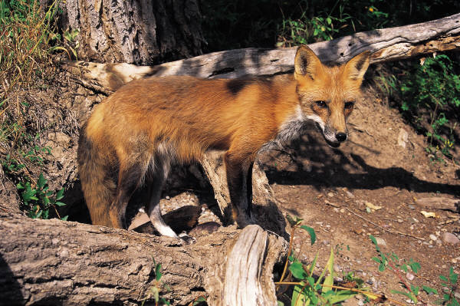
Beautiful – but what a pest he is. Did anyone have a steak that night? Do we still have two of these?
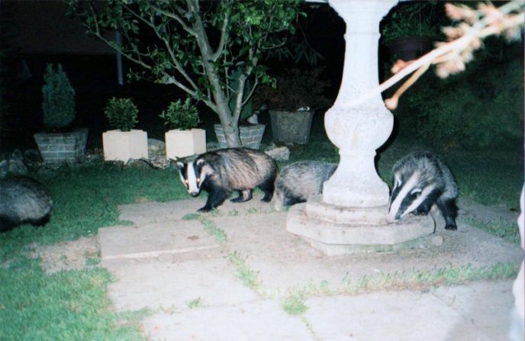
The ‘Ahh’ Factor Mr. Fox

And, of course, our Sadly, no longer with us
famous badgers!

These are just a few of the visitors to the Park not to
mention the 63 varieties of birds

